Water Tank Measurer Item Requirements

*Outline Document*

|  |  |  |  |
| --- | --- | --- | --- |
| **DOCUMENT DETAILS** | | | |
| ***Created by:*** | Connor Ryan | ***Created Date:*** | 15-OCT-2020 |
| ***Modified by:*** | Connor Ryan | ***Modified Date:*** | 15-OCT-2020 |
| ***Document ID:*** | N/A | ***Document Type:*** | Reference Document |
| ***Version:*** | A | ***Version Date:*** | 15-OCT-2020 |
| ***Update Details:*** | N/A | | |

Contents

Current Summary 3

Next Steps 3

Stage 1 (Software and Data Manipulation) 3

Stage 2 (Product design) 3

Stage 3 (Live Demo) 4

Item Requirements 4

Stage 1 4

Stage 2 4

1. Revision History 5

**Error! Hyperlink reference not valid.Error! Hyperlink reference not valid.Error! Hyperlink reference not valid.Error! Hyperlink reference not valid.Error! Hyperlink reference not valid.Error! Hyperlink reference not valid.Error! Hyperlink reference not valid.**

# Current Summary

Currently, the functioning parts of this project include code that sits on Ardunio and pulls the distance based on a Ultrasonic waterproof sensor. This data is then pushed to a mongoDB cloud database via the computers connection (Could potentially be Azure if necessary) for logging and future analysis.

After the data is logged into the database, it is then pulled back down to be displayed on a web server. Below is the current output that was being displayed from the Arduino’s sensors

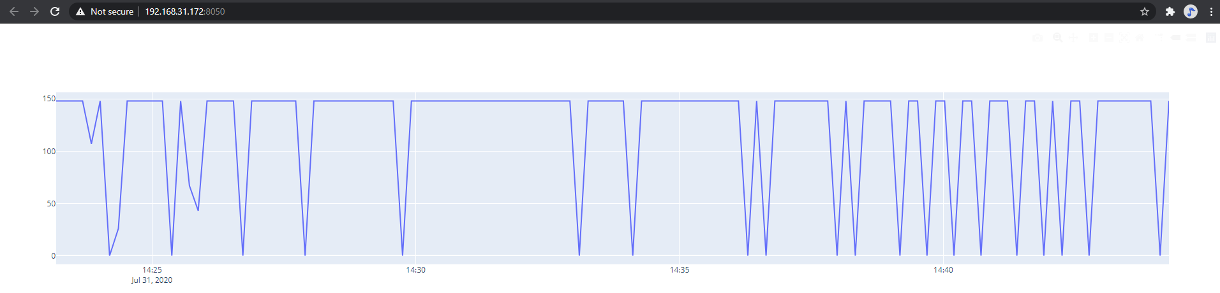

# Next Steps

## Stage 1 (Software and Data Manipulation)

We want to start using an IOT (can connect to the Wi-Fi) based board that we can load a sketch to and connect an external power supply to. With this we can start testing with larger buckets of water to determine volume.

I believe the board for this would Ideally be an Arduino uno Wi-Fi. It will allow for the loading of sketches and then with the right library I can build out a RESTful service to connect to a database. It has the added benefit of being significantly cheaper than the PI due to each Arduino only performing specific functions based on its model. It is also significantly faster as the native Arduino language complies into C++, which is a memory orientated language, is much more power efficient than the native Python of the Pi.

<https://store.arduino.cc/usa/arduino-uno-wifi-rev2>

With these pieces we can start testing bodies of water in the office, pulling data onto the board and pushing it to a database of our choice.

Ideally, in this stage we will determine our presentation method of the data as well, whether it will be exclusively web/desktop or style it for mobile as well and if we want to migrate to a ASP.Net core site or stick to the tried and true Flask Application.

## Stage 2 (Product design)

Once we are comfortable with the code and the data being pulled and pushed to the Cloud, we will need to get into the product design. This stage will focus on looking at the sensor in a real-world application and the requirements around it.

This is where the 3D printer will come in handy, we will need to design a waterproof container to hold the Arduino but still have holes to collect data and allow for a power supply to connect.

Due to not all water tanks being made the same, we will also need to decide on the power supply/connectivity method. If this is going to sit in a water tank will it be close to a power supply or will we need to utilise a Solar Panel/similar self-sustaining systems. If it is not close to a point of connectivity we will also have to determine how it will connect to the Cloud to send data, this may involve incorporating a 3G Dongle to the board or other hacky ways to get the data out.

## Stage 3 (Live Demo)

This stage is as the name suggests, a live demo. We will need to go visit someone who has a water tank that they are willing to let us use for a while, ideally several days (if there is rain around even better). This will allow us to collect a good dataset from the system and determine if there are any faults with the code/product design/parts, i.e. data becomes corrupted due to water leakage etc.

# Item Requirements

## Stage 1

|  |  |  |
| --- | --- | --- |
| Name | Cost | Link |
| Ardunio Board | $39.95 | <https://www.jaycar.com.au/uno-with-wi-fi/p/XC4411> |
| External Power Supply 12V DC | $ 29.95 | <https://www.jaycar.com.au/12v-dc-2-5a-power-supply-7dc-plugs/p/MP3490> |
| USB printer cable (Load Sketch from PC to board) | $4.88 | <https://www.officeworks.com.au/shop/officeworks/p/keji-2m-usb-type-a-to-type-b-cable-cou2pc02> |

## Stage 2

|  |  |  |
| --- | --- | --- |
| Name | Cost | Link |
| Ardunio Boards | $39.95 (potentially if breaks during stage 1) | <https://www.jaycar.com.au/uno-with-wi-fi/p/XC4411> |
| Recommended Soldering kit | $110.47 | <https://hakkousa.com/fx-888d-digital-soldering-station.html> |
| Self Sustain power supply (Solar) | Potential? (<https://www.cooking-hacks.com/documentation/tutorials/arduino-solar/index.html>) | <https://www.cooking-hacks.com/documentation/tutorials/arduino-solar/index.html> |